Samatar Abukar

Mr. Schattman

ICS 3UI

June, 13, 2014

Design document for the computer game *The Big Catch*

Game Description:

The Big Catch is a game that tests the users speed and reaction time with a mouse. The goal is to eat as many fish that swim towards you as you can before your lives run out.

You are to assume the role of the shark and will try to eat as many fish as you can and increase your score. There are several types of fish in the game:

* Small green fish (1 point)
* Medium yellow fish (2 points)
* Large red fish (3 points)
* Poison purple fish (-1 life)

The fish will come at you in waves and the speed of the fish increases after reaching a certain score to make the game more challenging. The game will end when you have no more lives because you either missed too many fish or caught too many poison fish or a combination of the two. Also, the user may quit at any time which will also end the game.

The shark may only move vertically at a constant speed.

Sketch of the Game Screen:

The game will look like this:

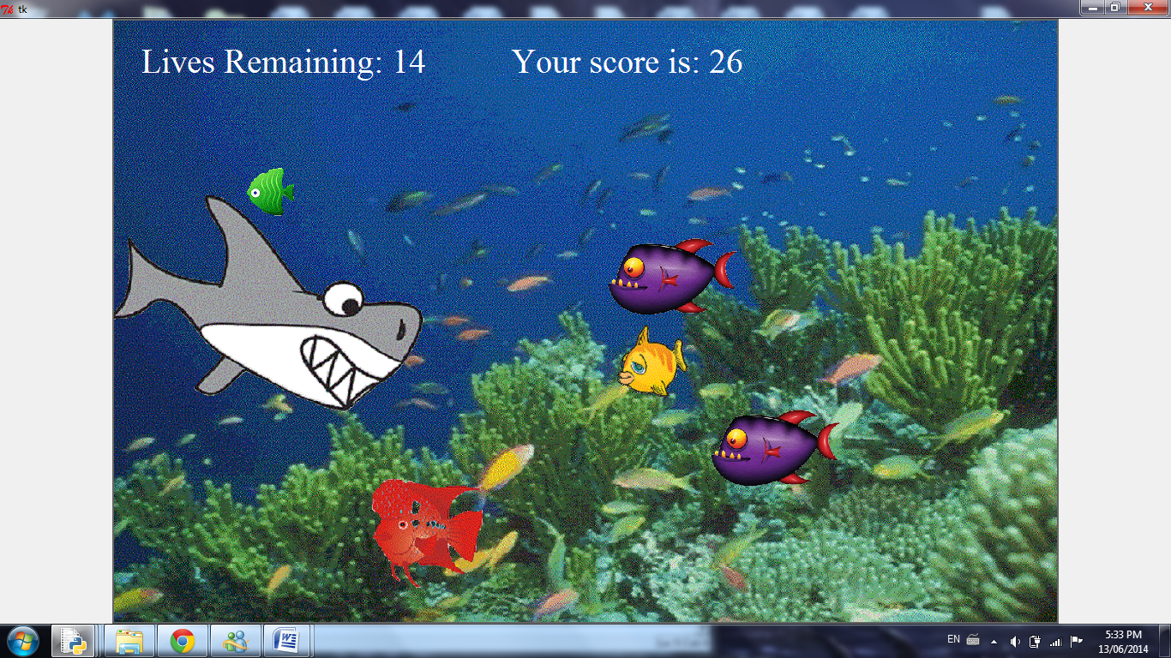

Instructions for Play:

To open the game click the Python file **TheBigCatch.py** and press F5.

There will be a screen showing you important information about the game that will last for four seconds. Afterwards, an ocean setting will appear and you will need move your mouse up or down to move the shark. As the fish swim at you, you will move the shark up or down to intercept and eat them.

To quit the game, press the **Q** key and all data will be erased.

Pseudocode algorithm for the runGame() procedure:

Shark starts off at left side of screen

Lives are set to 20 at start

score set to 0

While lives >0 **and** user has not press “Q”:

Fish will swim at shark from right to left left

They will appear in 3 rows with 2 additional rows for poison fish

As time passes fish speed **and** amount increase

If fish’s x and y values are close to the sharks mouth:

If green fish comes in contact with shark’s mouth:

Fish disappears

Score increases by 1

Elif yellow fish **comes** in contact with shark’s mouth:

Fish disappears

Score increases by 2

Elif red fish comes in contact with shark’s mouth:

Fish disappears

Score increases by 3

Elif purple fish comes in contact with shark’s mouth:

Fish disappears

Lives decrease by 1

Elif shark misses purple fish:

Nothing changes

Else: #When shark misses a good fish

Lives decrease by 1

If lives == 0 **or** player quits game:

Display “Game Over” screen